1. For every 100lb of acceptable product produced, Let x denote the number of lb of the crude insecticide used, and y the number of lb of the more refined insecticide used. Then the mathematical model is as follow:
Minimize 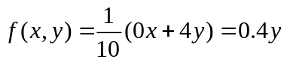
Subject to
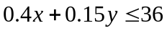 i.e. 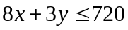
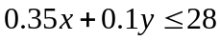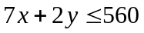
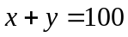
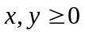. .

The feasible region is the bolded part of the line 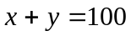 shown on the graph below. By comparing the objective function values given at both end points:
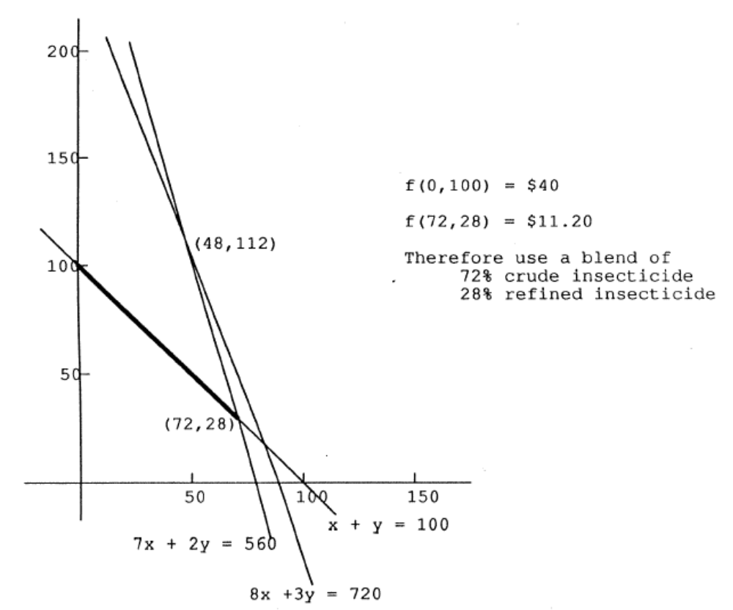 Hence we could conclude that to minimize the production costs, we should use 72% of the existing crude insecticide and 28% of the more refined insecticide to meet the federal standards. And each 100lb of such combination would cost $11.2.

2. Let x and y denote the member of elephants and donkeys to be produced, respectively. The mathematical model is:
Maximize 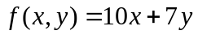
Subject to
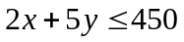
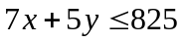
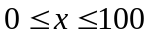
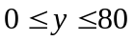.

The shade area is the feasible region. The optimal solution could be found by shifting the isocost line 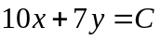 towards the upper right corner, or comparing the objective function values obtained at the five corners of the feasible region.
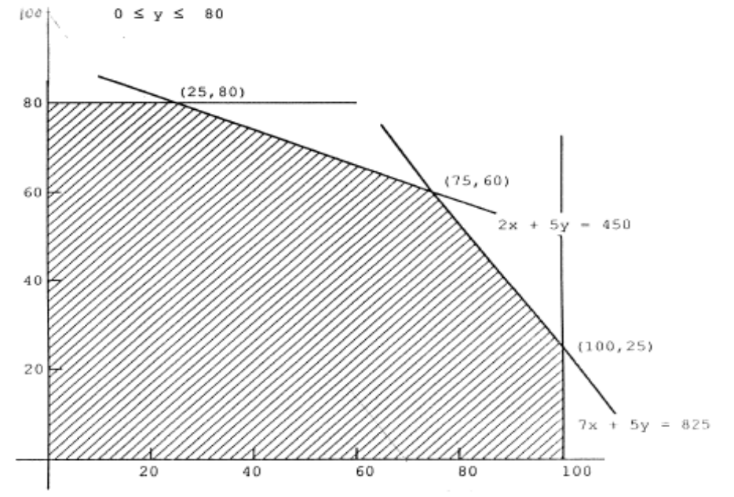
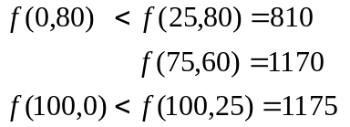
Therefore maximum profit of $1175 could be attained by producing 100 elephants and 25 donkeys.

3. Let C denote the number of cabinets installed, P the number of frames purchased and F the number of frames made internally. We have the model as:
Maximize
Subject to
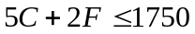
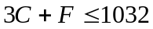
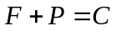
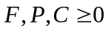.
It is equivalent to
Maximize 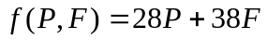
Subject to
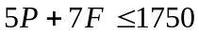
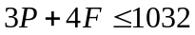
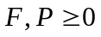
**If we are to solve this problem, the relevant vertices of the feasible region are (0,250), (224,90), (344,0); and gives the following objective function values:
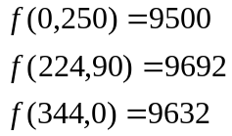
Therefore the maximum profit of $9692 could be attained by installing a total of 314 cabinets, while purchasing 224 of the necessary frames and preparing the remaining 90 internally.**

4. Let 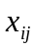denote the number of the units shipped from Warehouse i to Outlet j, and 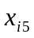 the number of units stored at warehouse i, where 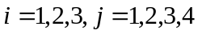. The problem can be modelled as:
Minimize 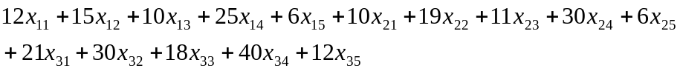
Subject to
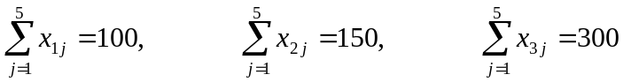
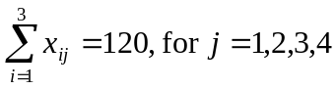
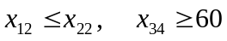
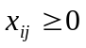for 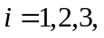and 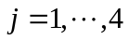.
5.
Let i=1,2,3, representing Aug., Sept., and Oct., respectively
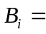number of units of refrigerators bought in month i;
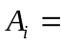number of units of refrigerators sold in month i;
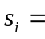number of units of refrigerators stored in month i;
The problem:
Maximize
Subject to
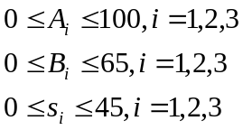
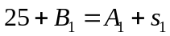
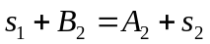
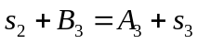

6.
For Quarter i, let
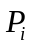= number of engines produced, up to 475
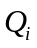= number of engines produced using overtime (i.e. number of engines produced above 475)
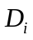= number of engines delivered
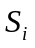= number of engines stored
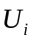= accumulated number of engines required but not delivered
The problem:
Minimize
Subject to
